Benefitting the
Huntsman Cancer
Institute
2010

Sigma Chi, Eta Lambda chapter
Virginia Tech
68 SPH-H Oak Lane
Blacksburg, VA 24060

Sigma Chi Charity Golf Tournament

April 14, 2012
9 a.m. Shotgun
Draper Valley Golf Course
Pulaski, VA

Our Eta Lambda Chapter is hosting the 5th annual Sigma Chi Charity Golf Tournament benefitting the Huntsman Cancer Institute. Based out of the University of Utah, the Huntsman Cancer Institute is a center designed to research possible treatments and preventions of cancer. Jon Huntsman, the founder of the Institute and a prominent Sigma Chi, has devoted his life to finding a cure for cancer. Already having had cancer twice in his lifetime, Huntsman has since donated $250+ million of his personal wealth to secure the dream of someday finding a cure.
The Sigma Chi fraternity added the Huntsman Cancer Institute as an additional beneficiary in 2005, along with the Children's Miracle Network as Sigma Chi International's two suggested charities. In the first year as a beneficiary, Sigma Chi chapters Internationally raised over $55,000 for the Huntsman Cancer Institute.
Starting two years ago, the annual Huntsman charity tournament began to have a deeper meaning. During the 2008 and 2009 school years, the Eta Lambda chapter lost two of our own to the ongoing fight to cancer. Duane Perdue ('03) was an integral part to the Undergraduate chapter, serving in a variety of leadership capacities. Duane was a dedicated brother who impacted many lives during his time at Virginia Tech and beyond. After an ongoing battle with Leukemia, he passed away in late 2008. One of the chapter's "sweethearts", Norrine Spencer, also passed after a stringent battle against breast cancer. Mrs. Spencer is the wife of longtime chapter and alumni advisor, Dr. Ed Spencer. Our chapter decided to honor Duane and Norrine by playing and donating the money raised each year in honor of them.

We have the bar exponentially high with this year's tournament. It's our hope that we can continue our strong partnership with the Huntsman Cancer Institute with a donation exceeding $6,000. Each year, we have raised more money than the year before and we hope this year is no different.
Thank you for your time in reading this and we hope that you will be able to join us in April!

Respectfully,
Mark Wilkinson, Co-Chair Daniel Hughes, Co-Chair Mitchell Murray, Co-Chair

Tournament Schedule:
A participating team after last year's tournament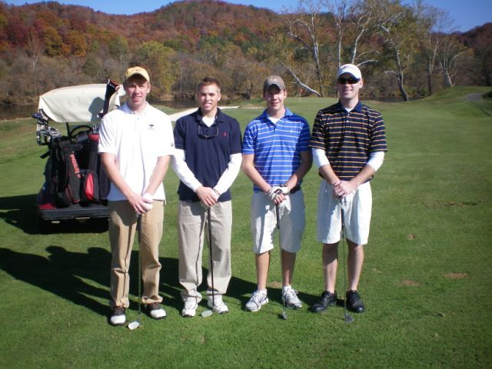

8 a.m. Registration
8:50 a.m. Line-up
9 a.m. Shotgun start
2 p.m. Lunch and Awards presentation

Format:
4-person Captains Choice tournament
Entry Fee: $75/person or $300/team (Includes green fees, cart, and food following the tournament)
Prizes awarded to the top 3 teams, as well as closest to the pin on Par 3's, and longest drive

Available for Purchase:
Mulligans: $5 each; Limit 4 per team
Raffle Tickets: $3 each (goes toward the post-tournament raffle)
"Red Tees": $5; Limit 2 per team

***All checks can be made payable to "Sigma Chi Philanthropy" by mailing to the following address:
Mark Wilkinson
304 Virginia Street
Blacksburg, VA 24060

Sponsorship Opportunities
$1000
$125
$500
$750

Company Name: _______________________________________________________________________
Type of Sponsor: _______________________________________________________________________
E-Mail: _______________________________________________________________________________
Payment Method:______________________________________________________________________
Phone Number: _______________________________________________________________________

*All sponsorships are tax deductable donations. Checks for sponsorships can be made out to “Sigma Chi Philanthropy”. Please send all sponsorship donations to Mark Wilkinson 304 Virginia Street, Blacksburg, VA 24060

Team and Player Information:
Name: _____________________________________________________________________________

Contact Information: _________________________________________________________________
Payment Method: ____________________________________________________________________
Dietary Restrictions: ___________________________________________________________________

Name: _____________________________________________________________________________

Contact Information: _________________________________________________________________
Payment Method: ____________________________________________________________________
Dietary Restrictions: ___________________________________________________________________

Name: _____________________________________________________________________________

Contact Information: _________________________________________________________________
Payment Method: ____________________________________________________________________
Dietary Restrictions: ___________________________________________________________________

Name: _____________________________________________________________________________

Contact Information: _________________________________________________________________
Payment Method: ____________________________________________________________________
Dietary Restrictions: ___________________________________________________________________

***All checks can be made payable to "Sigma Chi Philanthropy" by mailing to the following address:
Mark Wilkinson, 304 Virginia Street, Blacksburg, VA 24060

Questions?
You can contact the tournament chairmen at any time with questions regarding sponsorships, entry fees, and donations
Mark Wilkinson – mwilk13@vt.edu – (484)905-1315
Mitchell Murray – mbm12@vt.edu – (804)690-8945
Daniel Hughes – dano227@vt.edu – (804)787-3722

